Republic of the Philippines

Western Mindanao State University

**College of Computing Studies**

DEPARTMENT OF COMPUTER SCIENCE

Zamboanga City

**Gate Keeper: A Game-Based Approach to Logic  
Gates Learning in Higher and Secondary Education**

A Thesis Presented to the Faculty of

Department of Computer Science

College of Computing Studies

In Partial Fulfillment of the Requirements for the Degree of

Bachelor of Science in Computer Science

**JAZHEM M. HAMID**

**DAVE MATTHEW M. IGNACIO**

**EDWIN JR. A. COMEROS**

Researchers

**RHAMIRL B. JAFAAR**

Adviser

<Month and Year of Expected Graduation>

Republic of the Philippines

Western Mindanao State University

**College of Computing Studies**

DEPARTMENT OF COMPUTER SCIENCE

Zamboanga City

# Approval Sheet

The Thesis attached hereto, entitled **“Gate Keeper: Game-Based Approach to Logic Gates Learning in Higher and Secondary Education”**, prepared and submitted by **Jazhem M. Hamid, Dave Matthew M.Ignacio, Edwin Jr. A Comeros**, in partial fulfillment of the requirements for the degree of Bachelor of Science in Computer Science, is hereby **recommended for Oral Examination**.

**<ADVISER>**

Adviser

**APPROVED** by the Oral Examination Committee on **_______________** with a rating of **PASSED**.

**<PANEL 1>**

Chairperson

**<PANEL 2>**

Member

**<PANEL 3>**

Member

**Accepted** in partial fulfillment of the requirements for the degree of **Bachelor of Science in Computer Science**

**MS. LUCY FELIX-SADIWA, MSCS**

Head, Department of Computer Science

**RODERICK P. GO, Ph.D.**

Dean, College of Computing Studies

# Acknowledgment

# Abstract

# This research aim to improve learning and teaching logic-gates related topics through the use of an educational game that will be conducted on the second year students of Western Mindanao State University who are enrolled in the Digital Design subject, the research will produce results partaining to the effectiveness of the use of a game based approach rather that traditional methods of teaching logic gates, by creating an engaging and accurate game that gives students another venue to learn such a complex topic. the game comes equiped with single player mode for a more immersive and self based learning approach and a multiplayer for a more competitive mode, all this can be tracked and monitored by the educators who can use this tool as a teaching equipment for daily on and off campus learning. the game will gradually get harder as the student goes through the levels for a comprehensive learning experience.

# Table of Contents

Approval Sheet i

Acknowledgment ii

Abstract iii

Table of Contents iv

List of Figures vi

List of Tables vii

List of Appendices viii

CHAPTER I INTRODUCTION 1

Background of the Study 1

Statement of the Problem 2

Objectives 2

Scope and Limitations 3

Significance of the Study 3

Definition of Terms 3

CHAPTER II REVIEW OF RELATED LITERATURE 6

Related Studies 6

Synthesis 6

Conceptual Framework 7

Theoretical Framework 11

CHAPTER III METHODOLOGY 12

Research Design 12

Respondents 12

Data Gathering Instruments, Techniques, and Procedures 12

Statistical Tools 13

Analytical Tools 13

Technical Tools 13

Software Process Model 14

System Architecture 14

Deployment and Testing 14

CHAPTER IV RESULTS AND DISCUSSION 15

CHAPTER V CONCLUSION AND RECOMMENDATIONS 16

Conclusion 16

Recommendations 16

References 18

# List of Figures

Figure 1: Sample Conceptual Framework 7

Figure 2: Sample Conceptual Framework 8

# List of Tables

Table 1: Definition of Terms 4

Table 2: Synthesis 6

# List of Appendices

Appendix A: Gantt Chart 18

Appendix B: Survey Form 19

Appendix C: User Interface 20

Appendix D: Test Cases 21

Appendix E: Evaluation Tool 22

Appendix F: Relevant Source Code 23

Appendix G: User Manual 24

Appendix H: Plagiarism Report 25

Appendix I: Research Critique and Editing Certificate 26

Appendix J: Curriculum Vitae 27

# CHAPTER I INTRODUCTION

## Background of the Study

Consequently, the conventional way of teaching logical gates comprises explanations in textbooks and illustrations. It becomes a challenge for students who are uninterested in classroom activities to apply such knowledge in real-life situations. Theoretical understanding is different from practical application while teaching logic gates more profoundly. According to Tan and Venema (2019), many learners cannot comprehend how a logic gate operates because they only rely on symbolical representation thus do not know how the individual gates work together with others.

Efforts geared towards realizing effective game-based learning have been documented by Lin and Liu (2009) and Papastergiou (2009). Essentially, this research seeks to explore the capabilities of an interactive gami approach in actively engaging students. Through digital games, animated graphics and audio effects among others could be used to create an immersive experience that increases interest thereby increasing retention levels of acquired information. Consequently, another research seeks to give second year computer science students a lively dynamic game that uncovers logic gates by employing game-based learning principles.

The proposed game aims to address the specific challenges faced by students in comprehending and problem solving regarding the intricacies of logic gates, including understanding individual gate behaviors and their combinations to construct complex circuits.

## Statement of the Problem

## It is not easy to teach students about logic gates. The standard approach to teaching which often involves abstract ideas and theoretical explanations does not make the topic easy for learners to comprehend. Therefore, they become demotivated and disinterested.

## Subjects can be rendered more appealing and comprehensible through improved graphical representation. So teachers need interactive teaching aids. The plan is to create a game replicating and simulating the operation of logic gates as one of the alternatives. Moreover, the game can provide a platform where students learn while having fun with each other hence increasing their motivation in that particular subject area. This way it also gives teachers an important tool for checking progress made by his or her pupils besides being employed as a guide in teaching.

## This technique will facilitate better retention of concepts by ensuring enjoyable learning experiences for students thus promoting understanding among them. The desired outcomes are improved student comprehension of issues about logical gates and greater overall gains in learning too.

## Objectives

This study aims to teach and transfer knowledge about logic gates through an interactive puzzle game and improve their problem-solving skills.

Specifically, the study will:

* Gather data on the current standing of students understanding of logic gates by conducting a pre-test.
* Create an engaging logic gates game to improve students topic retention and problem solving
* To improved students accuracy on logic gate identification (AND, OR, NOT, NAND, NOR, XOR)
* To reduced time for students to solve logic gate puzzles.
* To help increased students scores on comprehensive logic gate exams.
* Compare the results between game-based learning users and traditional learning users by conducting a T-test.

## Scope and Limitations

The research centers on assessing how game-based learning influences comprehension of logic gates among computer science students at Western Mindanao State University during the academic year 2023-2024. To collect data regarding its effectiveness, a beta version of the game will be administered for analysis over an appointed time period.

The study's main objective is to compare the effectiveness of teaching logic gates topics using a game versus traditional methods. It does not aim to evaluate each student's eagerness for learning. The online capabilities of the game will be tethered connectivity only, and it is anticipated that there will be approximately 50 levels in total.

**Scope of Game-Based Logic Gate Learning Tool:**

* Target Users: This game will target second year computer science students who have a grounding in Boolean algebra.
* Logic Gate Coverage: The game will entail basic logic gates such as AND, OR, NOT, NAND, NOR and XOR.
* Learning Activities: The game will largely be based on puzzle solving activities involving logic gates with rising levels of challenges.
* Assessment: This can be facilitated by having internal assessments within the gameplay or providing data for external assessments which are made by the researcher.

**Limitations of Game-Based Logic Gate Learning Tool:**

* Focus on Fundamentals: With respect to advanced logic gate concepts or complex combinational circuits, these are not dwelt upon in this game.
* Stand-Alone Learning Tool: Although it seeks to improve comprehension, this game should not be used alone as an exclusive source for learning about logic gates. It needs to be utilized together with other course materials and teacher’s guidance in order to enhance understanding effectively.
* Quantitative Research Focus: The design of this game will mainly focus on obtaining information that relates to certain areas of investigation (accuracy, time taken to solve puzzles and examination grades) set during the process. Due to this reason, some possible ways of enhancing learning may not be explored fully using the existing resources.
* Technical Limitations: Depending on development resources and chosen platform there might be restrictions on graphical fidelity and complexity of puzzle mechanics in the game.

## Significance of the Study

The study will improve students knowledge on logic gates related topics by giving them a new and engaging way of learning by providing a logic-gates puzzle game that gradually teaches them the complexity of the subject.

The findings from this study will show if a game-based approach will have a significant effect on students performance that may then be used in future topics that may see an imporvement by utilizing a game-based system.

This study also brings value to the educators by giving them another pedagogic material to use in class, it will also help them monitor the performance of students by providing them a detailed report on the statistics of each student.

## Definition of Terms

Table 1: Definition of Terms

|  |  |
| --- | --- |
| **Term** | **Definition** |
| 1. Logic Gates | Learning logic gates is crucial if you’re studying electronics. These are significant electronic devices, mostly based on the Boolean function. Logic gates are used to provide a single binary output after performing logical operations on one or more binary inputs. Essentially, the electronic circuits within a digital system are known as logic gates.  **Reference**  [M_Waleed .2024 .circuits. Autodesk Instructables](https://www.instructables.com/Logic-Game-Using-Digital-Logic-Gates/)  By developing a mobile application for learning logic gates all the insights about logic gates is essential for the users will gain more knowledge. In our proposed study, every part of the game contains details about logic gates |
| 1. Game-Based Learning | Learning activities that include game characteristics and principles are referred to as game-based learning. Student participation and excitement for learning includes elements such as leaderboards, discussion boards, quizzes, badge systems, point systems, and classroom response systems. Game-based learning makes use of games to enhance student comprehension.  **Reference**  [Romas](https://elearningindustry.com/why-is-game-based-learning-important)  [Tamosevicious .2022. in elearningindustry.com .Why is game based learning is important.](https://elearningindustry.com/why-is-game-based-learning-important)  Our proposed study is a game-based learning that includes achievements, pre-test, post-test, results, and progress. |
| 1. Educational Technology | Many different aspects and elements of teaching and learning process are taken into consideration while evaluating educational technology. As a result, it supports all learning processes Defined concisely, it provides for the overall strategy and management of the educational system or subsystem. The area that regulates through education. Educational technology and learning improves teaching and learning while ignoring the robust and optimal outcomes that can be achieved economically with current human and non-human resources.  **Reference**  [Masturah Pakbin Alizada; Bibi Lina Azizi; and Tamana Setayesh .2023. Educational Technology and Mobile Learning. pressbooks.pub](https://pressbooks.pub/schools/chapter/educational-technology-and-mobile-learning/)  In our proposed study we need tools to develop the application. |
| 1. Tethered Connectivity | Tethering is the practice of sharing the internet connectivity of one device, typically a smartphone or tablet, with another device, such as laptop or another smartphone. In multiplayer mobile games require network connectivity to function. Players may interact directly with one another or with game servers over the internet.  **Reference**  [Cyberlinkasp .2023.Tethering: Network Access From Anywhere .cyberlinkasp.com](https://www.cyberlinkasp.com/insights/tethering-network-access-from-anywhere/)  In our proposed study it needs hotspot or wifi connectivity for the multiplayer mode. |
| 1. Post-test & Pre-test | Study methods called prestest and posttest are used to assess how well interventions or educational programs work. Posttesting zis giving a test to participants after the intervention or training is over, whereas pretesting entails giving a test to participants prior to any teaching or training. Assessing the change in knowledge, attitudes, or abilities between the two testing points is the aim of pretest and posttest study.  A post-test is an assessment tool given to participants after they went through some type of treatment as a part  of a research project, whereas a pretest is an assessment tool given to participants prior to any kind of treatment.    **Reference**  [Tiffany Budert-Waltz (Author) Jennifer Levitas (Expert Contributor) . 2023. Pretest-posttest Design | Definition, Types and Examples . study.com](https://study.com/learn/lesson/pretest-posttest-design-concept-examples.html)  In our proposed study users can take pre-test and post-test to evaluate their outcome. The post-test includes the questions that reflect the topics covered in the game levels assessing the user’s ability to apply the logic gate principles in different scenarios. |
| 1. Progressive Difficulty | This in known progressive difficulty, and it’s a strategy used by most linear games. The idea is that, despite the game’s initial challenge, it will eventually get easier for the player once he grasps its patterns. Progressive difficulty does not rely on “one size fits all” difficulty modifiers like standard difficulty settings do. Rather, every difficulty level modifies a certain feature of the game to increase the level of difficulty.  **Reference**  [A.J Catak .2019.How is mobile game’s difficulty level being optimized. quora.com](https://www.quora.com/How-do-video-games-implement-difficulty-levels)  In our proposed study, as the player progresses to higher levels, the difficulty level increases. |
| 1. Interactive Game | Interactive games are powerful learning tools that have been shown repeatedly to support the development of new abilities, knowledge, attitudes, and behaviors.  Interactive games are meant to provide entertainment, challenge players, and promote social engagement. Additionally, they can be educational, fostering teamwork, strategic thinking, and problem-solving skills.  **Reference**  [Lieberman Debra A. 2006 .What Can We Learn From playing Interactive Games?. in Research Gate University of California, Santa Barbara](https://www.researchgate.net/publication/285448990_What_Can_We_Learn_From_Playing_Interactive_Games) |
| 1. Problem-Solving | Games that test a player’s ability to think critically are known as problem solving games.  [Reference: Robinson Angela .Problem Solving Games, Activities & Exercises for Adults.](https://teambuilding.com/blog/problem-solving-games)  In our proposed study has an essence of a problem-solving skills which allows the player to interact with logic gates to improve their logic skills. |
| 1. Game Levels | Adaptive Learning algorithms are often used in educational games to customize the learning process. These algorithms modify the content and level of difficulty in accordance with the leaner’s development and performance.  The term “level” can signify several things in the context of a game. It can be used to describe a particular phase or part of a game, which gets difficult as the player’s experience points or level of progress in a game, which can influence their skills or access to particular materials.  **Reference**  [Laura Sky .2023.Mobile Game Development For Educational and Edutainment Apps. medium.com](https://medium.com/@laurasky729/mobile-game-development-for-educational-and-edutainment-apps-5bffed883392)  In our Levels is one of the important part of the game where the player starts to explore the logic gates and the game mechanics. |
| 1. Real-Time Challenges | Compared to other forms of testing, game testing is more intricate and unique. Live user testing, alpha testing, and a beta testing are necessary, but they are simply a few parts of larger puzzle. User involvement and experience are some areas where game testing varies from traditional app testing.  **Reference**  [Lakshmi Bhadoria .2022.Challenges in Mobile Testing (With Solutions). BrowserStack](https://www.browserstack.com/guide/mobile-testing-challenges)  By developing this kind of mobile application is a challenge to the developers because it needs a lot of testing and also the user will experience challenges as the game go further. |
| 1. Collaborative Learning | Collaboration is the key to success in the fast-paced world of game development. The combined efforts of many skills create the complex tapestry of an engrossing game emphasizing the value of cooperation and useful tools.  **Reference**  [DoreMatrix .2023.”Harmony in Pixels: The Essence of Collaboration in Game Development”. Linkedin](https://www.linkedin.com/pulse/harmony-pixels-essence-collaboration-game-development-dorematrix-b5iof)  In our proposed study we have a feature for the player to collaborate |
| 1. Visualizations | Graphics and artwork are examples of visual aspects that can influence sight, emotion, and the overall gaming experience. They assist players make sense of the game environment by shaping many different scenarios and adding to the immersive experience of video games.  **Reference**  [SCISPACE 2023.What is Significance of Game Art and Visuals in Video Games.typeset.io](https://typeset.io/questions/what-is-the-significance-of-game-art-and-visuals-in-video-3zyvg5n16s)  Visualization are also essential part of the development. |
| 1. Assessment Tools | Tools for assessment are ways to measure a student’s progress toward academic mastery in a subject as well as their academic aptitude, competency, and/or fluency in that subject.  **Reference**  [Dr. Berrisford Lewis .2021. Assessment: Evaluating Learners Progress and Achievement. Linkedin](https://www.linkedin.com/pulse/assessment-evaluating-learners-progress-achievements-lewis)  In our proposed study the assessment tools contains pre-test and post-test to track the users results and progress. |
| 1. Accessibility | When it comes to educational mobile games, accessibility means making sure the game is made in a way that makes it useable and inclusive for all players. To make the game accessible to a wide range of users, features, design principles, and usability standards must be implemented.  **Reference** [Barbara Leoprini & Eleonara Palmucci .2017.A Mobile Educational Game Accessible to All, Including Screen Reading Users on a Touch-Screen Device. SCISPACE](https://typeset.io/papers/a-mobile-educational-game-accessible-to-all-including-screen-50ffoauoka) |
| 1. Rules | A game’s rules specify how it should be played, what can and cannot be done. And how players should respond. They give the game a structure and guarantee that is fun and equitable for all participants.  **Reference**  [Michael Filimowicz .2023.Rules & Mechanics. Medium](https://medium.com/understanding-games/rules-mechanics-a7d7551193bc)  In our proposed study rules and tutorials of the game is essential |

# CHAPTER II REVIEW OF RELATED LITERATURE

## Related Studies

**Foreign Literature studies**

1. **E-Logic Trainer Kit : Development of an Electronic Educational Simulator and Quiz Kit for Logic Gate Combinational Circuit by using Arduino as Application (2019).**

This study discusses the integration of new technology in education, moving beyond traditional methods to include simulators and quiz kits in classrooms. These tools enhance teaching by offering real-life examples and improving test administration. The focus is in the development of the e-logic trainer kit (e-kit), utilizing Arduino technology to teach logic gates. The kit allows students to practice building various logic circuits and observe their functionality.

**Reference**

Mohammad Zulkarnian O., Amar Faiz Z.A, Syahrul Hisham M., Nur Dalila K.A, N.Ismail .2019. E-Logic Trainer Kit: Development of an Electronic Educational Simulator and Quiz Kit for Logic Gate Combinational Circuit by using Arduino as Application Vol.15 No.14 (2019) https://online-journals.org/index.php/i-joe/article/view/11410

1. **Development and Evaluation of an Educational Game to Practice the Truth Tables of Logic (2019).**

This study discusses the struggle if computer Science students with understanding logic concepts, leading to procrastination and lack of comprehension. Researchers developed an educational game, derived from a card game and adapted for proposition logic as a mobile app, to address this issue. Through iterative improvements and feedback, the game was found effective and suitable for students, potentially replacing traditional exercises. However, integration into the course was deemed necessary to ensure universal student engagement with the game.

**Reference**

[Olga De Troyer, Renny Linberg, Jan Maushagen, Pejman Sajjadi .2019. Development and Evaluation of an Educational Game to Practice the Truth Tables of Logic](https://ieeexplore.ieee.org/abstract/document/8820859/authors" \l "authors)

[https://ieeexplore.ieee.org/abstract/document/8820859/authors#authors](https://ieeexplore.ieee.org/abstract/document/8820859/authors" \l "authors)

1. **Learning Logic Gate through 7-Gates (2020)**

An educational game called “7 Gates Digital World” uses a future adventure setting to teach logic gates. In order to advance through the stages and fuel the virtual world engine. Players must use logic gates algorithms. Players must gather switches in challenging platform maps in order to progress in this puzzle-platform game. The game is essentially a teaching tool, offering material levels dependent in the player’s comprehension and promoting memory of gate formulas, despite its difficult genre.

**Reference**

[Hanasrullah Halim, Wan Amirah Najwa Wan Idris, Haslina Hassan, Ismail Yusuf Panessai.2020. Learning Logic Gates through 7-Gates](https://lamintang.org/journal/index.php/ijmari/article/view/70/51)

<https://lamintang.org/journal/index.php/ijmari/article/view/70/51>

1. **Interactive M-Learning Media Technology to Enhance the Learning Process of Basic Logic Gate Topics in Vocational School and Engineering Education(2020)**

The study introduces BLG-LeMed, a mobile learning application developed to help high school students learn the fundamentals of logic gates. Extreme Programming (XP) was ised in the development of the program, while usability assessments, alpha testing, and user acceptability tests (UAT) were used in testing. 38 students participated in the study, which watched them utilized BLG-LeMed in class. The findings show that BLG-LeMed is well-liked by users, functions as an engaging educational tools, inspires students to learn, and produces good learning results.

**Reference**

[Aulia Akhrian Syahidi, Afif Supiano, Herman Tolle, Tsukasa Hirashima .2020. Interactive M-Learning Media Technology to Enhance the Learning Process of Basic Logic Gate Topics in Vocational School and Engineering Education.vol.2(2), 2020. https://www.researchgate.net/publication/350016075_Interactive_M-Learning_Media_Technology_to_Enhance_the_Learning_Process_of_Basic_Logic_Gate_Topics_in_Vocational_School_and_Engineering_Education](https://www.researchgate.net/publication/350016075_Interactive_M-Learning_Media_Technology_to_Enhance_the_Learning_Process_of_Basic_Logic_Gate_Topics_in_Vocational_School_and_Engineering_Education)

1. **Construction of a Web Game for the Teaching-Learning Process of Electronics during the COVID-19 Pandemic (2022)**

This study created a digital game, DGE version 3.0, to teach combinational circuits during the COVID-19 pandemic. Fifteen engineering students participated. Results indicate the game positively impacted student’s understanding and skills in electronics. The study highlights the effectiveness of a web gaming for remote learning.

**Reference**

[Sala Rueda, Ricardo Adan, Alvarado Zamorano, Clara, Ramirez Ortega .2022. Construction of a Web Game for the Teaching-Learning Process of Electronics during the COVID-19 Pandemic (2022)](https://eric.ed.gov/?id=EJ1356743) <https://eric.ed.gov/?id=EJ1356743>

1. **Teaching Digital Circuit Design With a 3-D Video Game: The Impact of Using In-Game Tools on Students’ Performance (2020)**

This study examines how engineering student’s performance in a digital circuit design course is impacted by in-game tools. They examined three different kinds of tools: productivity tools, scaffold, and instructional help. The findings indicated that while productivity tools had no discernible impact, guidance and scaffolding aids enhance learning performance.

**Reference**

[Mehmet Oren, Susan Pedersen, Karen L. Butler-Purry Teaching Digital Circuit Design With a 3-D Video Game: The Impact of Using In-Game Tools on Students’ Performance (2020).](https://ieeexplore.ieee.org/document/9130891) <https://ieeexplore.ieee.org/document/9130891>

1. **DESIGNING AN EDUCATIONAL ANDROID APPLICATION TO IMPROVE LEARNING QUALITY AND STUDENTS' ATTITUDES TOWARDS IT (2021)**

The aim of this project is to create an Android application for education that will improve learning outcomes and replicate computer logic gates. It aims to solve the problems with traditional education by improving the accessibility, interest, and error-reduction of learning logic gates. The results demonstrate that the experimental group’s comprehension of logic gates significantly improved when compared to the control group, demonstrating the efficacy of the instructional mobile application.

**Reference**

[Doaa M. Hawa, ELSAEED M. Abdelrazek M. Saad .2021. DESIGNING AN EDUCATIONAL ANDROID APPLICATION TO IMPROVE LEARNING QUALITY AND STUDENTS' ATTITUDES TOWARDS IT vol.17. 2021](https://www.jlls.org/index.php/jlls/article/view/4249) <https://www.jlls.org/index.php/jlls/article/view/4249>

1. **The Development of Educational Game Based Learning Media Increases Computer System Learning Motivation in Vocational High Schools (2024)**

Study focuses on developing educational game-based learning media to increase student motivation in Computer Systems subjects. It addresses the lack of student engagement with traditional text-based learning materials. Following the ADDIE model (Analyze, Design, Development, Implementation, Evaluation) the study found that the developed educational game-based media was feasible and positively impacted student’s learning motivation. The results indicate increased motivation among students after using educational game-based media, highlighting its effectiveness in enhancing learning experiences.

**Reference**

Rohmania Agustin Pramana Putri, Heru Wahyu Heru Wahyu Herwanto, .2024. The Development of Educational Game Based Learning Media Increases Computer System Learning Motivation in Vocational High Schools .2024.

<https://www.atlantis-press.com/proceedings/veic-23/125997720>

1. **Exploring the Fusion of Mixed Reality and Digital Game-Based Learning: The Case of Puzzle Box Games for Education (2023)**

This study discusses the disadvantages of online learning as well as the difficulties experienced by conventional offline teaching techniques during the COVID-19 pandemic. Inspired by the idea of a puzzle box, the study explores the merging of digital game-based learning and mixed reality technologies to address these problems. The goal of the study is to improved learning outcomes and student engagement through the design of virtual digital puzzles with an emphasis on user-centered human-computer interaction. The ease of use gameplay aspects of mixed reality puzzle box games encourage students to use them for instructional reasons, according to the results, which enhances the learning process.

**Reference**

[Boon Giin Lee, Huimin Tang, Xinlei Wen .2023. Exploring the Fusion of Mixed Reality and Digital Game-Based Learning: The Case of Puzzle Box Games for Education .2023.](https://ieeexplore.ieee.org/abstract/document/10398389)

<https://ieeexplore.ieee.org/abstract/document/10398389>

1. **A Multiplayer Learning Game Design to Improve Online Learning Experiences (2023)**

The challenges of lacking social connection in online learning and its detrimental effects on cognitive and motivational elements are discussed in this study. It explores studies on online learning to find optimal approaches for creating solution. The goal is to develop a cooperative, multiplayer learning game that teaches principles related to digital electronics. Based on secondary and primary research, the study creates an entertaining two-player web game to support group learning and practice of digital circuits.

Reference:

[Vyas, Falguni .2023. A Multiplayer Learning Game Design to Improve Online Learning Experiences .2023.](https://www.proquest.com/openview/b49f2b2c7aab071ed6df0ff8c80ce8f3/1?pq-origsite=gscholar&cbl=18750&diss=y)

<https://www.proquest.com/openview/b49f2b2c7aab071ed6df0ff8c80ce8f3/1?pq-origsite=gscholar&cbl=18750&diss=y>

**Local Literature studies**

1. **LogIO: An Adaptive Gamification Learning Approach on Digital Logic Gates** (2020)

This study investigates the impact of game design elements on learner’s motivation, performance, and learning experience in a gamified e-learning model for digital logic gates. Thirty learners evaluated the LogIO application, revealing high levels of motivation and usability, with performance and learning experience levels of 81% The results underscore the importance of tailored design elements in gamified learning to enhance motivation, performance, and learning experience.

**Reference**

[JO Torio, RT Bigueras, D E Maligat, Jr. , MA Arispe, and JS Dela Cruz .2020. LogIO: An Adaptive Gamification Learning Approach on Digital Logic Gates .2020.](https://iopscience.iop.org/article/10.1088/1757-899X/803/1/012008/pdf)

<https://iopscience.iop.org/article/10.1088/1757-899X/803/1/012008/pdf>

1. **A Gamified Approach on Learning Logic Gates to Improve Student's Engagement** **(2019)**

This study aims to propose a framework for developing a gamified learning application for digital logic gates to enhance student engagement. It explores existing research and design principles to identify relevant parameters for measuring student engagement. The framework serves as a guide for game developers, aiming to standardize the development process of gamified learning in digital logic subjects, ultimately improving student engagement.

**Reference**

[JO Torio, RT Bigueras, DE Maligat Jr. MA Arispe, and JS Dela Cruz .2019.A Gamified Approach on Learning Logic Gates to Improve Student's Engagement .2019](https://iopscience.iop.org/article/10.1088/1757-899X/803/1/012007/meta).

<https://iopscience.iop.org/article/10.1088/1757-899X/803/1/012007/meta>

## Synthesis

Table 2: Synthesis (Foreign Literature Studies)

**Foreign Literature Studies**

|  |  |  |  |  |  |  |  |  |  |  |  |
| --- | --- | --- | --- | --- | --- | --- | --- | --- | --- | --- | --- |
| **Feature** | **Study 1** | **Study 2** | **Study 3** | **Study 4** | **Study 5** | **Study 6** | **Study 7** | **Study 8** | **Study 9** | **Study 10** | **Proposed Study** |
| 1. Mobile App | **🗸** | **🗸** |  | **🗸** |  |  | **🗸** |  |  |  | **🗸** |
| 1. Learning Modules | **🗸** | **🗸** | **🗸** | **🗸** | **🗸** | **🗸** |  | **🗸** | **🗸** | **🗸** | **🗸** |
| 1. Real-time challenges |  | **🗸** | **🗸** |  | **🗸** | **🗸** | **🗸** | **🗸** | **🗸** | **🗸** | **🗸** |
| 1. Visualization | **🗸** | **🗸** | **🗸** | **🗸** | **🗸** | **🗸** | **🗸** | **🗸** | **🗸** | **🗸** | **🗸** |
| 1. Collaborative Learning |  | **🗸** | **🗸** |  |  | **🗸** |  |  |  | **🗸** | **🗸** |
| 1. Customizable Matches |  |  |  |  |  |  |  |  |  |  | **🗸** |
| 1. Educator Resource |  |  |  |  |  |  |  |  |  |  | **🗸** |
| 1. Customization Options |  |  |  |  |  |  |  |  |  |  | **🗸** |
| 1. Progressive Difficulty Levels |  | **🗸** | **🗸** |  |  | **🗸** | **🗸** | **🗸** |  |  | **🗸** |
| 1. Assessment Tools |  |  | **🗸** |  |  | **🗸** | **🗸** | **🗸** | **🗸** |  | **🗸** |
| 1. Saving Progress |  |  |  |  |  | **🗸** | **🗸** | **🗸** | **🗸** | **🗸** | **🗸** |
| 1. Time Constraints |  |  | **🗸** |  |  |  | **🗸** |  |  |  | **🗸** |
| 1. Rules and Instructions | **🗸** |  | **🗸** | **🗸** | **🗸** | **🗸** | **🗸** | **🗸** | **🗸** |  | **🗸** |
| 1. Proactive Feedback |  |  | **🗸** |  |  |  |  |  |  |  | **🗸** |
| 1. Story board |  |  | **🗸** |  |  |  |  | **🗸** |  |  | **🗸** |
| 1. Tutorial with Video Demonstration |  |  |  |  |  |  |  |  |  |  | **🗸** |

Table 3: Table 2: Synthesis (Local Literature Studies)

**Local Literature Studies**

|  |  |  |  |  |  |  |  |  |  |  |  |
| --- | --- | --- | --- | --- | --- | --- | --- | --- | --- | --- | --- |
| **Feature** | **Study 1** | **Study 2** | **Study 3** | **Study 4** | **Study 5** | **Study 6** | **Study 7** | **Study 8** | **Study 9** | **Study 10** | **Proposed Study** |
| 1. Mobile App | **🗸** |  |  |  |  |  |  |  |  |  | **🗸** |
| 1. Learning Modules | **🗸** | **🗸** |  |  |  |  |  |  |  |  | **🗸** |
| 1. Real-time challenges | **🗸** | **🗸** |  |  |  |  |  |  |  |  | **🗸** |
| 1. Collaborative Learning |  | **🗸** |  |  |  |  |  |  |  |  | **🗸** |
| 1. Customizable Matches |  |  |  |  |  |  |  |  |  |  | **🗸** |
| 1. Educator Resource |  |  |  |  |  |  |  |  |  |  | **🗸** |
| 1. Customization Options |  |  |  |  |  |  |  |  |  |  | **🗸** |
| 1. Progressive Difficulty Levels | **🗸** | **🗸** |  |  |  |  |  |  |  |  | **🗸** |
| 1. Assessment Tools | **🗸** |  |  |  |  |  |  |  |  |  | **🗸** |
| 1. Saving Progress | **🗸** | **🗸** |  |  |  |  |  |  |  |  | **🗸** |
| 1. Time Constraints | **🗸** | **🗸** |  |  |  |  |  |  |  |  | **🗸** |
| 1. Rules and Instructions | **🗸** | **🗸** |  |  |  |  |  |  |  |  | **🗸** |
| 1. Proactive Feedback |  |  |  |  |  |  |  |  |  |  | **🗸** |
| 1. Story board | **🗸** | **🗸** |  |  |  |  |  |  |  |  | **🗸** |
| 1. Tutorial with Video Demonstration |  |  |  |  |  |  |  |  |  |  | **🗸** |

Therefore, All the related literature studies there some features are not available to improve the learner’s knowledge and interest to learn logic gates like Customizable Matches for the users can create personalized matches with specific objectives or rules to target particular concepts or skills, Assessment Tools including pre-and post-test evaluations, will be incorporated into the game to assess students' comprehension and monitor their advancement, Educator Resources for the game will offer resources for educators, such as lesson plans and guides on effectively incorporating the game into their curriculum.

## Conceptual Framework

Figure1: Logic Gates Mobile Game Conceptual Framework

1. **Single player**

First of all, in the single player mode this will be the introduction and the background of the game that contains levels, tutorials, and post-test. In post-test after playing some of the levels of the game including pre-test, users can take post-test to evaluate their outcome. The post-test includes the questions that reflect the topics covered in the game levels assessing the user’s ability to apply the logic gate principles in different scenarios.

1. **Assessment Module**

In assessment module it includes the pre-test. In the pre-test users take a pre-test to gauge their baseline knowledge of logic gates and digital circuits. Questions and puzzles are presented to assess the user’s understanding of fundamental concepts.

1. **Creative Mode**

In Creative mode, users can experiment with logic gates freely. They can design and construct their own digital circuits, test their functionality, and observe the output. This mode encourages exploration and hands-on learning, allowing the users to reinforce their understanding of logic gates through practical experimentation.

1. **Multiplayer**

In multiplayer mode offers users the opportunity to engage in real-time competition with other players, fostering a sense of camaraderie and motivation to excel in logic gate challenges. Users can join or host multiplayer challenges where they compete against each other in solving logic gate puzzles or constructing circuits. Therefore, the system need an internet connection.

1. **Accounts**

User accounts allow players to have unique identities within the game, which is essential for saving progress and multiplayer interactions. With user accounts, users can create and customize profiles.

1. **Wifi Direct**

Wifi Direct allows mobile games to discover and connect to nearby devices within the Bluetooth range. This can be used to facilitate various gameplay features such as device synchronization, or sharing game content between players.

## Theoretical Framework

1. **LogIO: An Adaptive Gamification Learning Approach on Digital Logic Gates (2020).** “In contemporary education, e-learning is widely utilized, particularly in higher education, to enhance teaching and learning experiences. One effective method to achieve this is through gamification, which aims to increase effectiveness, motivation, performance, and overall learning experience for students. While gamification has gained popularity in higher education, integrating it properly is crucial for its positive impact on both teaching and learning processes, leading to increased satisfaction, motivation and engagement among learners. Despite numerous studies providing various game design elements, determining which specific elements truly influence learner motivation, performance, and learning experience remains a challenge. Therefore, employing game design principles effectively is essential in motivating learners, subsequently leading to improved learning outcomes. In fields like teaching digital logic gates, where complex concepts require hands-on demonstrations, gamified approaches have shown promise. In the Philippines, The Department of Education Secretary Leonor M. Briones, advocates for the adoption of innovative teaching methods, emphasizing the need for ICT instructors to utilize strategies that promote creativity and motivation among learners, signaling a timely adoption of gamification in education. Numerous studies have explored various game design elements, which can complicate the development and implementation of a gamified logic gate application. This study aims to identify most significant and relevant game design elements for the development of the gamified LogIO. Key elements such as story and rules, points, levels, challenges, leaderboards, and time constraints were identified as crucial for this purpose. For instance, the game begins with presenting the story and rules, followed by the player earning points and progressing through level before advancing, maintaining engagement. Completing challenges unlocks rewards for enhanced performance and learning experiences. Leaderboards are incorporated to boost motivation through ranking and statistics. Additionally, time constraints are introduced to gauge player performance and facilitate learning. Overall, these carefully selected game design elements aim to optimize player engagement and learning outcomes in the gamified application.”

**Reference**

[JO Torio, RT Bigueras, D E Maligat, Jr. , MA Arispe, and JS Dela Cruz .2020. LogIO: An Adaptive Gamification Learning Approach on Digital Logic Gates .2020.](https://iopscience.iop.org/article/10.1088/1757-899X/803/1/012008/pdf)

<https://iopscience.iop.org/article/10.1088/1757-899X/803/1/012008/pdf>

1. **Learning logic gate through 7 gates (2020).** “This game offers as simple yet effective method for students to learn about logic gates through an educational game with futuristic adventure theme. It aims to address the evolving educational needs, especially concerning high technologies and industry In Malaysia, secondary schools have begun teaching about logic gates, promoting game designers to cater to teenagers and educational needs. The game provides an opportunity for gaming enthusiasts to engage in beneficial gaming enthusiast to engage in beneficial experiences. It stands out by using a digital circuit theme and allowing users to explore a digital world imagined by the developers. The gameplay involves a simulation followed by puzzle-solving, with challenges like collecting switches. Progression through levels is contingent upon completing task and answering logic gate questions correctly. Key mechanics, such as locked levels, questions retries, switch collection, and levels restarts, are seamlessly integrated into the gameplay facilitate learning without explicit explanation to the players. As the game currently comprises levels, the developers aim to enhance it further if given the opportunity, aligning with future educational needs and technological advancements. ”

**Reference**

[Hanasrullah Halim, Wan Amirah Najwa Wan Idris, Haslina Hassan, Ismail Yusuf Panessai.2020. Learning Logic Gates through 7-Gates](C:\\Users\\Programmer\\Downloads\\Hanasrullah Halim, Wan Amirah Najwa Wan Idris, Haslina Hassan, Ismail Yusuf Panessai.2020. Learning Logic Gates through 7-Gateshttps:\\lamintang.org\\journal\\index.php\\ijmari\\article\\view\\70\\51)

[https://lamintang.org/journal/index.php/ijmari/article/view/70/51](C:\\Users\\Programmer\\Downloads\\Hanasrullah Halim, Wan Amirah Najwa Wan Idris, Haslina Hassan, Ismail Yusuf Panessai.2020. Learning Logic Gates through 7-Gateshttps:\\lamintang.org\\journal\\index.php\\ijmari\\article\\view\\70\\51)

Both research studies aims to enhance learning experiences through gamification, particularly in teaching digital logic gates. However, they have different approaches and implementations.

When it comes to engagement and motivation, LogIO: An Adaptive Gamification Learning Approach on Digital Logic Gates (2020) utilizes a variety of gamification elements such as points, levels, and leader boards, which are known to enhance motivation and engagement. Learning logic gate through 7 gates (2020) relies on puzzle mechanics to engage learners.

While it is interesting this might not provide as much positive feedback as logIO’s organized

Gamification features. In terms of learning development, students are guarantee to understand concepts prior to passing through stages provided by the logIO(2020). Learning complicated subjects like digital logic gates might be aided by using this guided practice method. A simulation and puzzle platform are provided by learning Logic gates through seven gates (2020), although it lacks apparent advancement of LogIO (2020). There may be gaps in knowledge when learners develop their own speed.

Through the feedback feature, LogIO(2020) provides immediate feedback including leaderboards and points, encouraging students to keep going when they make the right answers. Compared to the feed back systems in LogIO(2020). Learning logic gates with 7 gates(2020) offers feedback by retrying questions and results for wrong answers, which may be less immediate and motivating. In comparison, LogIO (2020) seems to be more useful for understanding digital logic gates. Its structured gamification elements, immediate feedback, and clear learning progression provide a more robust framework for enhancing motivation, engagement, and learning outcomes and most of its features is similar to our proposed title. Our approach is to improve our proposed study by analyzing the strategies of the other related studies. Therefore we need to consider incorporating a comprehensive evaluation methodology similar to LogIO. This could involve pre-test and post-test, surveys, and qualitative feedback to measure the game’s impact on student learning outcomes.

Explore ways to relate the content and objectives of the game to computer science. This can improve the applicability and relevance of the game for students. Include learning analytics and must include tools in the game that allow the users to monitor the progress and results to offer students insightful information. In collaborative learning we must look for ways to include components of collaborative learning in the game so that students can cooperate to share knowledge and solve problems by playing the game together.

This can strengthen understanding and develop collaboration. The proposed study must conduct a longitudinal studies to evaluate the lasting effects of the educational game on student’s learning outcomes and their career paths within the field of computer science. Through monitoring student’s advancement and witnessing how their abilities and understanding grow over time, we can acquire significant understanding of the game has a long-lasting beneficial influence on student’s academic performance and computer science career choices.

# CHAPTER III METHODOLOGY

## Research Design

**Research Problem:**

How to improve the learning experience and messure the difference between a game based learning approached compared to the traditional way of teaching and learning.

**Review previously published literature:**

Previous studies show merrit in the game-based learning approach in educational institutes that boosts user engagement and enjoyment which correlates to motivation to learning.

**Hypothesis:**

Develop a game that improves the knowledge of students regarding logic gates.

**Required data and how it will be obtained:**

* **Pre-test and Post-test Assessments:**

Results on the ingame pre-test and post-test would be compaired. It will be obtained via written and ingame tests.

* **Player Feedback and Surveys:**

Users feedback on complete feel of the game, tactfulness, helpfullness, usablitiy and impact on their education.

* **Performance Metrics:**

To make an interesting logic gate game, we will develop a system that is well designed with the goal of minimizing errors and ensuring an enjoyable gaming experience. We make sure every player has a flawless gaming experience. User input acts as our compass, guiding us as we make adjustments and perfect the game. With a focus on perfection, we are dedicated to providing an incredible gaming experience that gamers will love.

**Narrative description of the methods of analysis for testing the hypothesis:**

To test our hypothesis, we first determine how easy it is for players to find and play our logic gate game. We then start playing the game ourselves to ensure that everything works properly. We want to make sure it works well on devices, such as phone and that it's enjoyable to play. Once we're satisfied, we ask others to try it out and let us know what they think. Their feedback allows us to make any final changes to make the game even better.

## Respondents

This Reseach will use **Purposive Sampling**: This method involves selecting participants based on specific criteria that align with the research objectives..

**Second year computer science students**

The main participants would be the 2nd year students of the computer science department in Western Mindanao State University who are currently enrolled in the digital design subject.

## Data Gathering Instruments, Techniques, and Procedures

Our online survey form for gathering data on logic gates game development begins with an introduction that explains its objective. It collects demographic data and evaluates players' experience with logic gate games. Questions assess perceptions, preferences, and feedback regarding game elements and learning outcomes. Open-ended sections allow participants to provide further comments and suggestions. The survey ends with a note expressing gratitude and a promise of privacy. See Appendix E.

## Statistical Tools

**1. Paired Samples t-Test:** This test is ideal for comparing the means of two related groups (pre-test and post-test) from the same sample of students. It's suitable for analyzing:

* Improved Accuracy on Logic Gate Identification: You can compare the average number of correctly identified logic gates on pre and post-tests to assess if the game improved accuracy.

**Formula (assuming equal variances):**

t = (Mean_Posttest - Mean_Pretest) / (Standard Deviation_Pooled √(n-1))

**Where:**

* t = t-statistic value
* Mean_Posttest = Average score on post-test
* Mean_Pretest = Average score on pre-test
* Standard Deviation_Pooled = Pooled standard deviation (estimated from both pre and post-test data)
* n = Sample size (number of students)

2. Paired Samples Signed-Rank Test:

* **Reduced Time to Solve Logic Gate Puzzles:** To compare the signed differences in time taken to solve puzzles before and after the game to see if there's a statistically significant decrease in solving time.

3. Mean (Average): Calculated by adding all the score for a variable and dividing by the total number of scores

4. Standard Deviation (Grouped): The range of data points around the mean. It can be used to determine the consistency of student performance or feedback scores.

## Analytical Tools

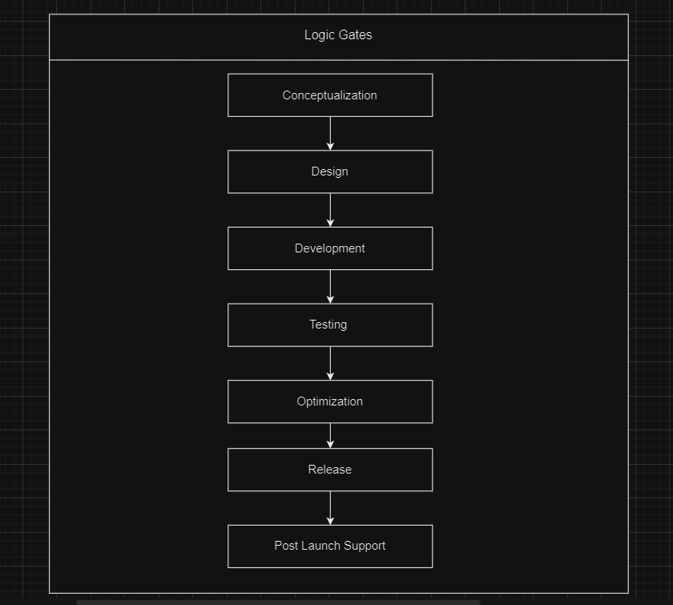

This figure depicts the step-by-step procedure of creating our game development (Logic Gates). It begins with conceptualization, then progresses to design and development, testing and iteration, and finally optimization. Once its already release support and updates are offered to keep players or gamers engaged. Each steps helps to create an entertaining logic gate game experience.

## Technical Tools

Programming Languages:

Various programming languages are used in game development to implement game logic, mechanics, and interactions.

C#, C++, and JavaScript are commonly used languages for scripting gameplay in Unity, while Unreal Engine primarily utilizes C++ for coding game logic.

**Hardware Devices:**

|  |  |  |
| --- | --- | --- |
| **Hardware Device** | **Application** | **Tool Usage** |
| Mobile Devices (Smartphones, Tablets) | Game testing, mobile platform optimization | Compared Version |
| Computer/ Laptop | Game development, coding, testing | Track changes in game performance access device |
| Graphic Processing Unit (GPU) | Rendering complex graphics, visual effects | Identify graphics |
| Headsets | Immersive gaming experience | Enhance sense of presence and engagement. |

## Software Process Model

## 

This figure depicts an organized software process model for logic gates game creation, with stages ranging from conceptualization to post-launch support. It assists developers with ideation, requirements gathering, design, development, testing, optimization, release, and continuing support. This simple approach provides a path guide for quick and effective game creation, resulting in a polished and entertaining finished work.

## System Architecture

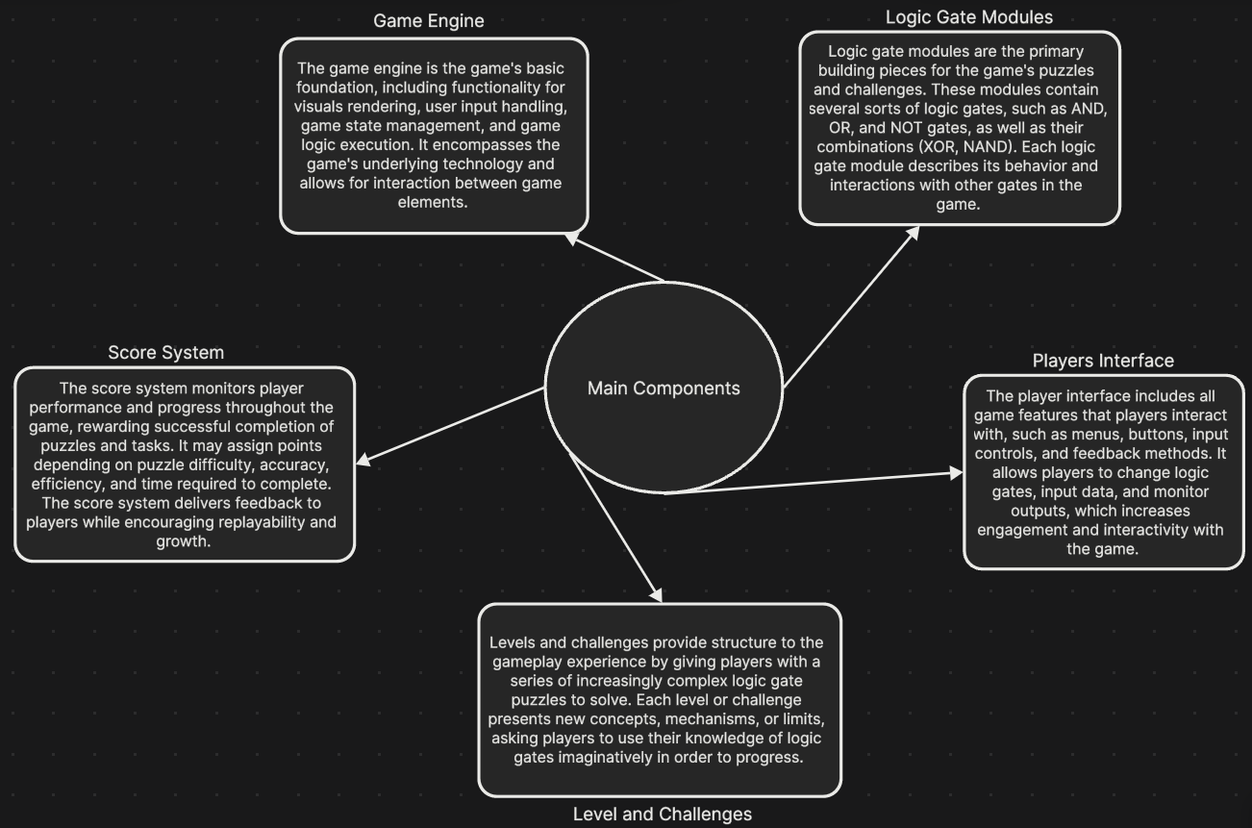

The game engine is the engine room, making everything run smoothly. The logic gates module is the brain, cooking up all the brain-teasing puzzles. And keeping score? That's like having a scoreboard, tracking our progress and achievements.

Then there's the level design team, who are like the architects, designing all the fun challenges. And finally, the player's interface, That's the front gate, welcoming players in and guiding them through the adventure.

**Deployment and Testing**

Before players can get their hands on our logic gates game, we’ll make it accessible by putting it where they can find it like app stores or gaming platforms. So, we’re going to play it ourselves a lot. We test every button, every level, and every feature to catch any bugs or problems. We want players to have the best experience possible, so we fix any issues we find and make sure everything works perfectly before they start playing our game.

**Appendix A: Gantt Chart**

**A – PROJECT WORKPLAN**

**(1) Program Title**

**(2) Project Title: Gate Keeper: A Game-Based Approach to Logic Gates Learning in Higher and Secondary Education**

**(3) Project Duration (number of months):** ______12______

**(4) Project Start Date: January 1, 2024**

**(5)** **Project End Date: December 31, 2024**

|  |  |  |  |  |  |  |  |
| --- | --- | --- | --- | --- | --- | --- | --- |
| **(6) OBJECTIVES** | **(7) TARGET ACTIVITIES** | **(8) TARGET ACCOMPLISHMENTS**  (quantify, if possible) | **Y1** | | | | |
| **Q1** | **Q2** | **Q3** | **Q4** | **Total** |
| Analyze Current Educational Practices | Review existing educational materials on logic gates. | Identify key teaching methods and concepts used in current materials. |  |  |  |  |  |
| Analyze online lectures and platforms for effective teaching strategies. | Compile a list of effective online teaching strategies and their applications. |  |  |  |  |  |
| Collaborate with educators specializing in logic gates for insights and challenges. | Gather insights and challenges faced by educators in teaching logic gates. |  |  |  |  |  |
| Develop an Interactive Logic Gates Game | Design game mechanics and levels. | Develop a detailed plan outlining the game's mechanics and levels. |  |  |  |  |  |
| Develop visual and interactive elements for the game. | Create high-quality visual and interactive elements for the game. |  |  |  |  |  |
| Integrate educational content on logic gates into the game. | Integrate educational content seamlessly into the game mechanics and levels. |  |  |  |  |  |
| Conduct beta testing with students to gather feedback. | Obtain feedback from students to improve the game's functionality and educational value. |  |  |  |  |  |
| Evaluate the Effectiveness of the Game | Design pre-and post-test evaluations to measure student learning outcomes. | Develop assessments to measure student understanding before and after playing the game. |  |  |  |  |  |
| Collect data from beta testing to assess the game's impact. | Gather data on the game's impact on student learning and engagement. |  |  |  |  |  |
| Analyze data to determine the game's effectiveness in teaching logic gates. | Analyze collected data to determine the game's effectiveness as an educational tool. |  |  |  |  |  |
| Refine and Improve the Game Based on Feedback | Review feedback from beta testing and evaluation results. | Identify key areas for improvement based on feedback. |  |  |  |  |  |
| Identify areas for improvement in the game. | Determine specific aspects of the game that need improvement to enhance the learning experience. |  |  |  |  |  |
| Implement changes to enhance the game's effectiveness and engagement. | Make necessary changes to the game based on feedback and evaluation results. |  |  |  |  |  |
| Conduct additional testing to ensure improvements are effective. | Test the game after implementing changes to ensure improvements have been effective. |  |  |  |  |  |

**Appendix B: Survey Form**

1. How familiar are you with logic gates and basic digital circuits?
   1. Very familiar
   2. Somewhat familiar
   3. Not familiar at all
2. Have you ever used any educational games to help you gain knowledge?
   1. Yes
   2. No
3. Have you ever used any educational tools or games to learn about logic gates or digital circuits before?
   1. Yes
   2. No
4. What do you hope to achieve by playing a logic gates game?
   1. Gain a better understanding of how logic gates work
   2. Improve problem-solving skills
   3. Learn to design and analyze digital circuits
   4. Other (please specify)
5. How would you rate your interest in puzzle-solving games?
   1. Very interested
   2. Somewhat interested
   3. Not interested
6. What platform(s) do you prefer for playing games?
   1. PC
   2. Mobile (iOS/Android)
   3. Console (PlayStation, Xbox, etc.)
7. How important is it for you to have a visually appealing interface in a game?
   1. Very important
   2. Somewhat important
   3. Not important
8. Would you prefer a single-player or multiplayer mode for the logic gates game?
   1. Single-player
   2. Multiplayer
   3. Either is fine
9. How challenging would you like the game to be?
   1. Very challenging
   2. Moderately challenging
   3. Mildly challenging
10. Do you prefer a storyline or narrative in the game, or are you more interested in straightforward gameplay?
    1. Prefer storyline/narrative
    2. Prefer straightforward gameplay
    3. No preference
11. What additional features would you like to see in a logic gates game?

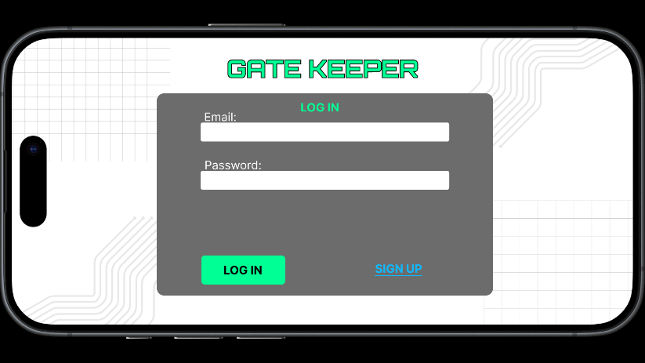**Appendix C: User Interface**

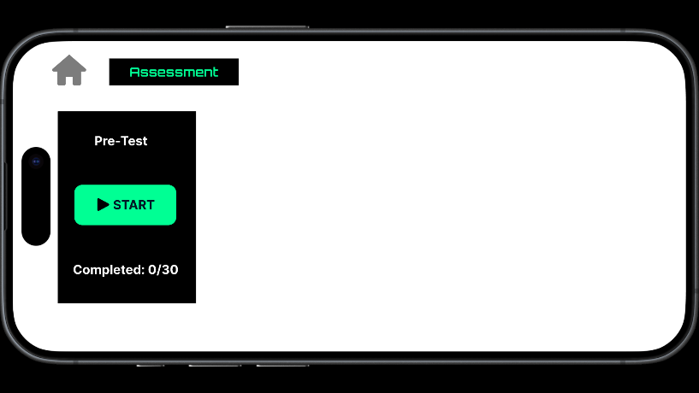

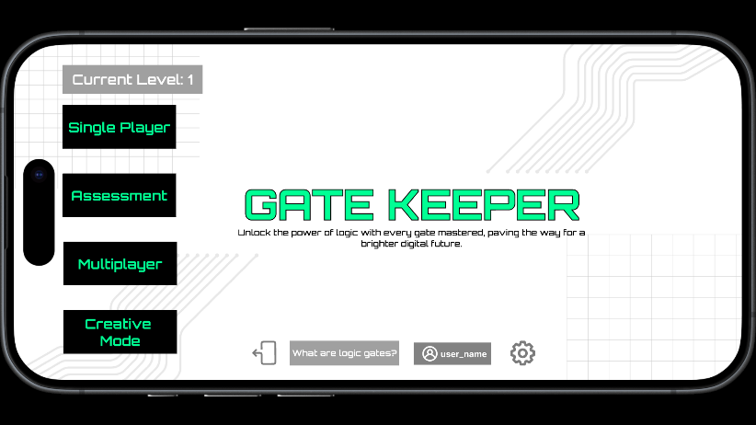

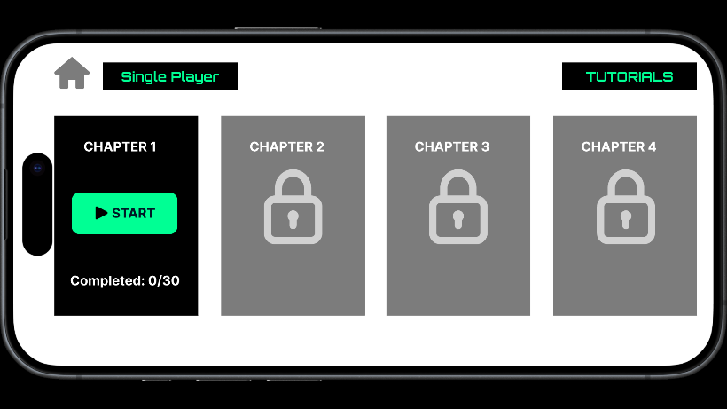

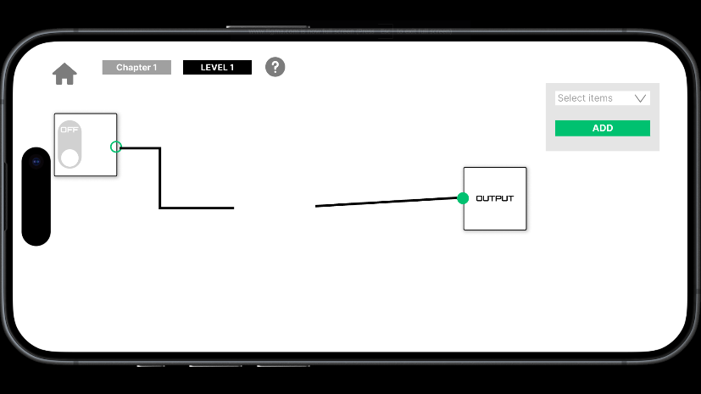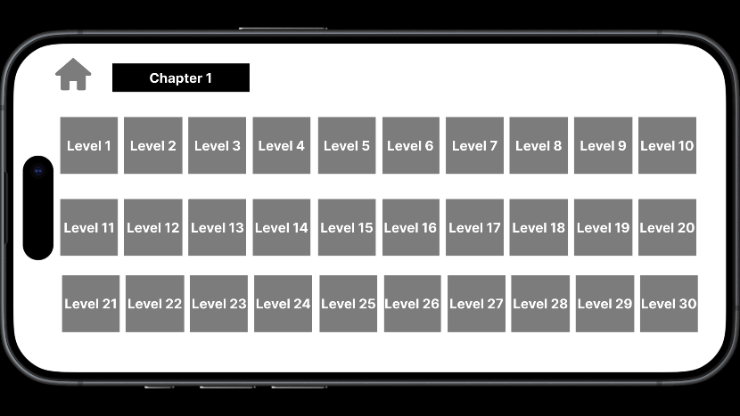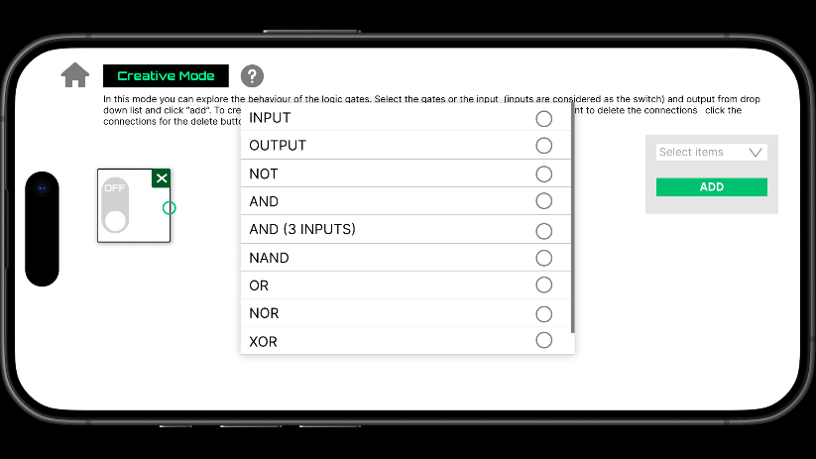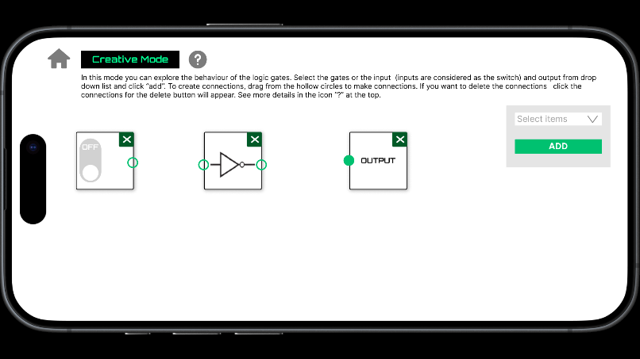

**Appendix D: Test Cases**

**Functionality Test Cases:**

**1. Input Validation:**

* Test that the game handles invalid input correctly (e.g., entering incorrect logic gate inputs).
* Verify that the game provides appropriate error messages for invalid inputs.

**2. Logic Gate Operations:**

* Test the functionality of each logic gate (e.g., AND, OR, NOT) to ensure they perform the correct operations.
* Verify that the game produces the correct output based on the input logic gates.

**3. Level Progression:**

* Test the game's ability to advance to the next level after completing a level successfully.
* Verify that the game displays the correct level progression and unlocks new levels as expected.

**Performance Test Cases:**

**1. Load Testing:**

* Test the game's performance under different load conditions (e.g., varying numbers of players, levels, and complexity).
* Verify that the game maintains acceptable performance levels without lagging or crashing.

**2. Resource Utilization:**

* Test the game's resource utilization (e.g., memory, CPU) to ensure it does not exceed acceptable limits.
* Verify that the game optimally utilizes resources for smooth gameplay.

**Security Test Cases:**

**1. Data Encryption:**

* Test the game's data encryption methods to ensure sensitive information is protected.
* Verify that the game uses secure encryption algorithms and practices.

**Appendix E: Evaluation Tool**

**QUESTIONS**

1. What is the output of an AND gate if both inputs are 1?
2. 0
3. 1
4. 1, 0
5. Cannot be determined
6. Which logic gate produces an output that is the complement of its input?
7. AND Gate
8. OR gate
9. NOT gate
10. XOR gate
11. What is the output of an OR gate if both inputs are 0?
12. 0
13. 1
14. 2
15. Cannot be determined
16. Which gate produces an output if 1 if either or both inputs are 1?
17. AND gate
18. OR gate
19. NOT gate
20. XOR gate
21. What is the output of an XOR gate if both inputs are the same?
22. 0
23. 1
24. None
25. Cannot ne determined
26. Which gate produces an output of 1 only if both inputs are different?
27. AND gate
28. OR gate
29. NOT gate
30. XOR
31. What is the output of an NAND gate if both inputs are 1?
32. 0
33. 1
34. 0.0
35. None of the above
36. Which gate produces an output of 0 only of both inputs are 1?
37. AND gate
38. OR gate
39. NOT gate
40. NAND gate
41. What is the output of a NOR gate if both inputs are 0?
42. 0
43. 1
44. 2
45. None of the above
46. Which gate produces an output of 1 only if both inputs are 0?
47. AND gate
48. OR gate
49. NOT gate
50. NOR gate

**True or False**

11._______The output of an AND gate is 1 only if all of its inputs are 1.

12._______ A NOR gate produces an output of 0 if any of its inputs are 1.

13._______The output of an XOR gate is 0 both inputs are the same.

14._______The output of a NAND gate is always the component of the output of an AND gate with the same inputs.

15._______ A NOT gate produces the complement of its input

16._______ A XOR gate is equivalent to an OR gate followed by NOT gate

17._______The output of a NOR gate is 1 if and only if all of its inputs are 0.

18._______ A XNOR gate produces an output of 1 only if both inputs are different

19._______The output of a NAND gate is 1 only of both of its inputs are 0.

20._______An OR gate with one input inverted is equivalent to a NOR gate.

# References

*Eric Zhi Liu and Chun Hung Lin. 2008. Developing evaluative indicators for educational computer games. British Journal of Educational Technology 40, 1 (December 2008), 174–178. DOI:http://dx.doi.org/10.1111/j.1467-8535.2008.00852.x*

*Marina Papastergiou. 2009. Digital game-based learning in High School Computer Science Education: Impact on educational effectiveness and student motivation. Computers &amp; Education 52, 1 (January 2009), 1–12. DOI:http://dx.doi.org/10.1016/j.compedu.2008.06.004*

*Wee Lum Tan and Sven Venema. 2019. Using physical logic gates to teach digital logic to novice computing students. Proceedings of the 6th International Conference on Educational Technologies 2019 (February 2019). DOI:http://dx.doi.org/10.33965/icedutech2019_201902l002*

**Appendix A: Gantt Chart**

**Appendix B: Survey Form**

**Appendix C: User Interface**

**Appendix D: Test Cases**

**Appendix E: Evaluation Tool**

**Appendix F: Relevant Source Code**

**Appendix G: User Manual**

**Appendix H: Plagiarism Report**

**Appendix I: Research Critique and Editing Certificate**

**Appendix J: Curriculum Vitae**